SIMATS ENGINEERING
ASSESSMENT TOOL 3: Modelling Comparative Analysis Assignment
COURSE NAME: | ARTIFICIAL INTELLIGENCE AND EXPERT SYSTEMS | COURSE CODE: | MLA01

COURSE OUTCOME COVERED
CO 5: Construct rule-based expert systems using production rules, forward and backward chaining, and by distinguishing procedural and non-procedural paradigms across development stages.(BTL 3)
Assessment Tool Weightage: 40%
Total Marks: 100 Time: 90 Mins
No. of Questions: 1
Annexure A
Modelling Comparative Analysis Assignment

Code of Conduct:
I SAHIL J.S (192525200) (Name / Reg No) certify that this submission is my original work and that I have adhered to the guidelines specified for this assessment.
I understand that any violation of academic integrity rules will result in disciplinary action.
Signature of the student: Sahil J.S
Criterion | Weightage (%) | Marks Obtained
1. Problem Analysis and Domain Understanding | 10%
2. Domain Knowledge and Fact Identification | 10%
3. Production Rule Modelling | 15%
4. Propositional Logic Modelling | 10%
5. First-Order Logic Modelling | 15%
6. Prolog Modelling and Implementation | 15%
7. Forward and Backward Chaining Demonstration | 10%
8. Comparative Analysis of Modelling Approaches | 10%
9. Results, Discussion and Model Selection | 3%
10. Documentation, GitHub Repository and Presentation | 2%
Total | 100%

Signature of the Faculty Total Marks Awarded

1. Problem Statement & Objectives
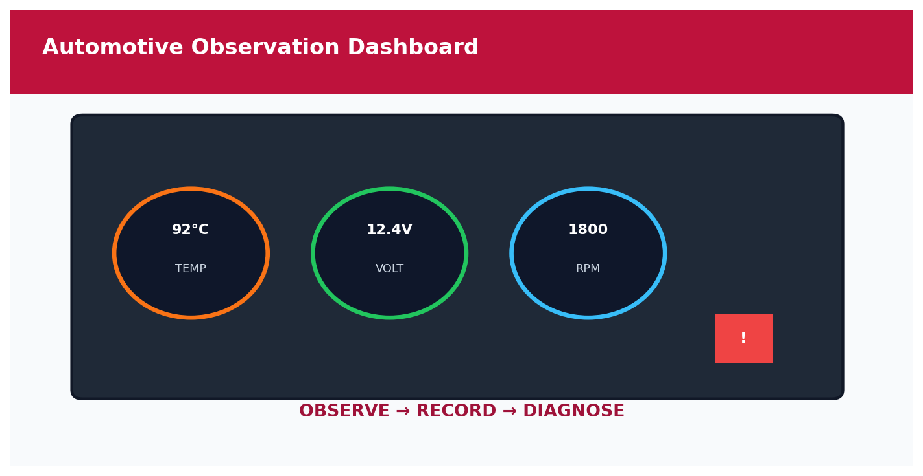
Automotive Observation Dashboard
Automotive Domain – Engine Observation Panel
An automobile service center wants to identify vehicle faults based on symptoms such as engine overheating, starting failure, abnormal noise, low mileage and warning indicators. The problem is modelled using production rules, propositional logic, first-order logic and Prolog. The approaches are compared using expressiveness, inference, complexity, scalability, flexibility, explainability and suitability.
Element | Description
Domain | Automobile service-center fault diagnosis.
Decision | Map observed symptoms to probable faults.
Models | Production rules, propositional logic, FOL and Prolog.
Reasoning | Forward and backward chaining.
Outcome | Select the most suitable model.

Automotive Domain – Observable Facts

2. Domain Knowledge & Fact Identification
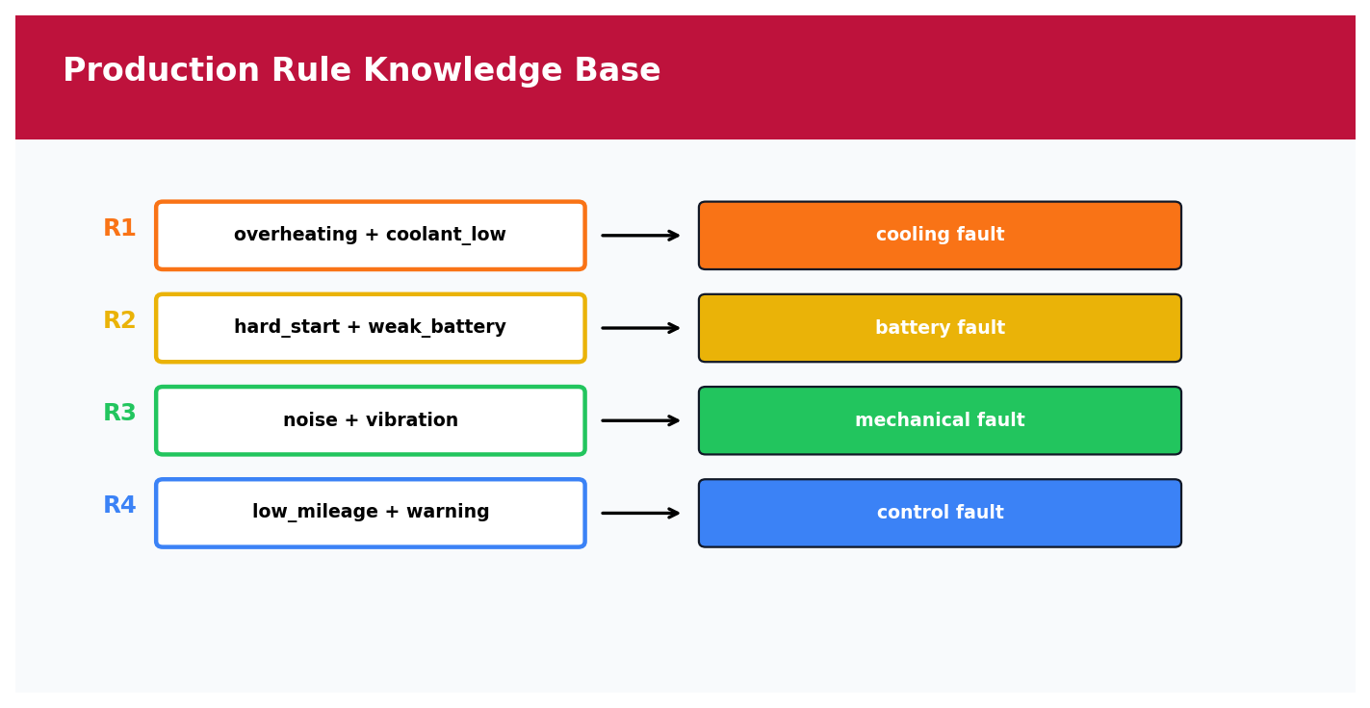
Production Rule Knowledge Base
Production Rule Knowledge Base
The domain contains observable symptoms, vehicle components, fault categories, relationships, conditions and diagnostic conclusions.
Category | Examples
Symptoms | engine_overheating, hard_start, abnormal_noise, low_mileage, warning_light
Supporting facts | coolant_low, weak_battery, engine_vibration
Components | engine, battery, cooling_system, fuel_system
Faults | cooling_system_issue, battery_starting_issue, engine_mechanical_issue
Actions | check coolant, test battery, inspect components, scan codes

Symptoms | Conclusion
engine_overheating + coolant_low | cooling_system_issue
hard_start + weak_battery | battery_starting_issue
abnormal_noise + engine_vibration | engine_mechanical_issue
low_mileage + warning_light | fuel_or_engine_control_issue

3. Production Rule Modelling

Production Rule Knowledge Base
Production Rule Knowledge Base
Production rules represent the knowledge as readable IF–THEN statements.
Rule | IF | THEN
R1 | engine_overheating AND coolant_low | cooling_system_issue
R2 | hard_start AND weak_battery | battery_starting_issue
R3 | abnormal_noise AND engine_vibration | engine_mechanical_issue
R4 | low_mileage AND warning_light | fuel_or_engine_control_issue
R5 | engine_overheating AND warning_light | cooling_system_issue
R6 | hard_start AND warning_light | starting_or_engine_control_issue

Symptoms → Check conditions → Rule fires → Fault conclusion → Diagnostic action

4. Propositional Logic Modelling
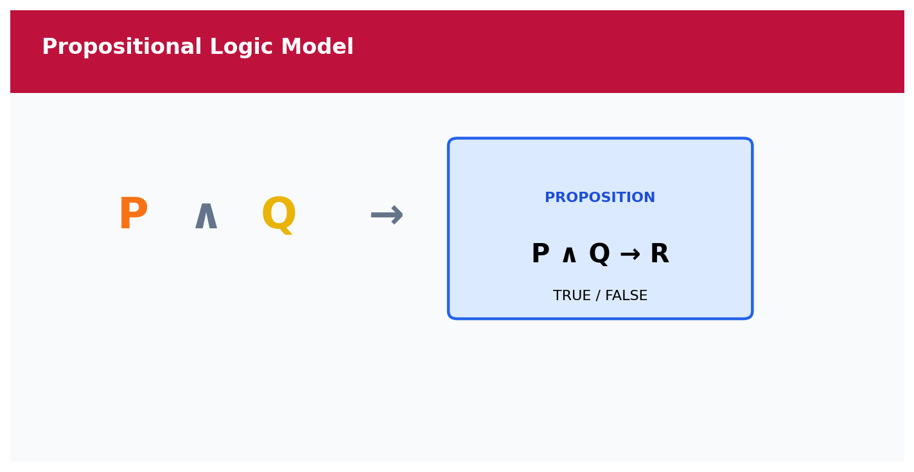
Propositional Logic Model
Propositional Logic Representation
Each relevant statement is represented as a proposition with a true/false value.
Symbol | Meaning
O | Engine is overheating
C | Coolant is low
H | Vehicle has hard-start condition
B | Battery is weak
N | Abnormal noise is present
V | Engine vibration is present
M | Mileage is low
W | Warning indicator is active
F1 | Cooling-system issue
F2 | Battery/starting issue
F3 | Engine mechanical issue
F4 | Fuel/engine-control issue

O ∧ C → F1
H ∧ B → F2
N ∧ V → F3
M ∧ W → F4
O ∧ W → F1
Knowledge Modelling Pipeline

5. First-Order Logic Modelling
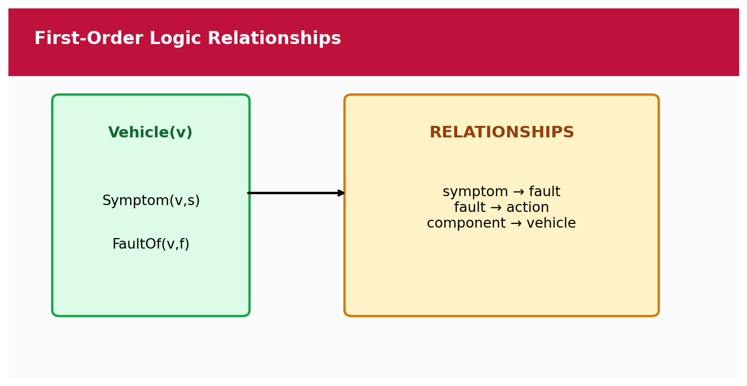
First-Order Logic Relationships
First-Order Logic – Entities & Relationships
First-Order Logic adds variables, predicates and relationships, making it possible to represent many vehicles and components without creating a separate proposition for every object.
Predicate | Meaning
Vehicle(v) | v is a vehicle
Symptom(v,s) | vehicle v has symptom s
Fault(f) | f is a possible fault
FaultOf(v,f) | fault f is associated with vehicle v
Action(f,a) | action a is associated with fault f
Component(v,c) | vehicle v contains component c

∀v [Symptom(v,engine_overheating) ∧ Symptom(v,coolant_low) → FaultOf(v,cooling_system_issue)]
∀v [Symptom(v,hard_start) ∧ Symptom(v,weak_battery) → FaultOf(v,battery_starting_issue)]
∀v [Symptom(v,abnormal_noise) ∧ Symptom(v,engine_vibration) → FaultOf(v,engine_mechanical_issue)]
FOL is more expressive than propositional logic because it can represent general relationships using variables and quantified statements.

6. Prolog Modelling & Implementation
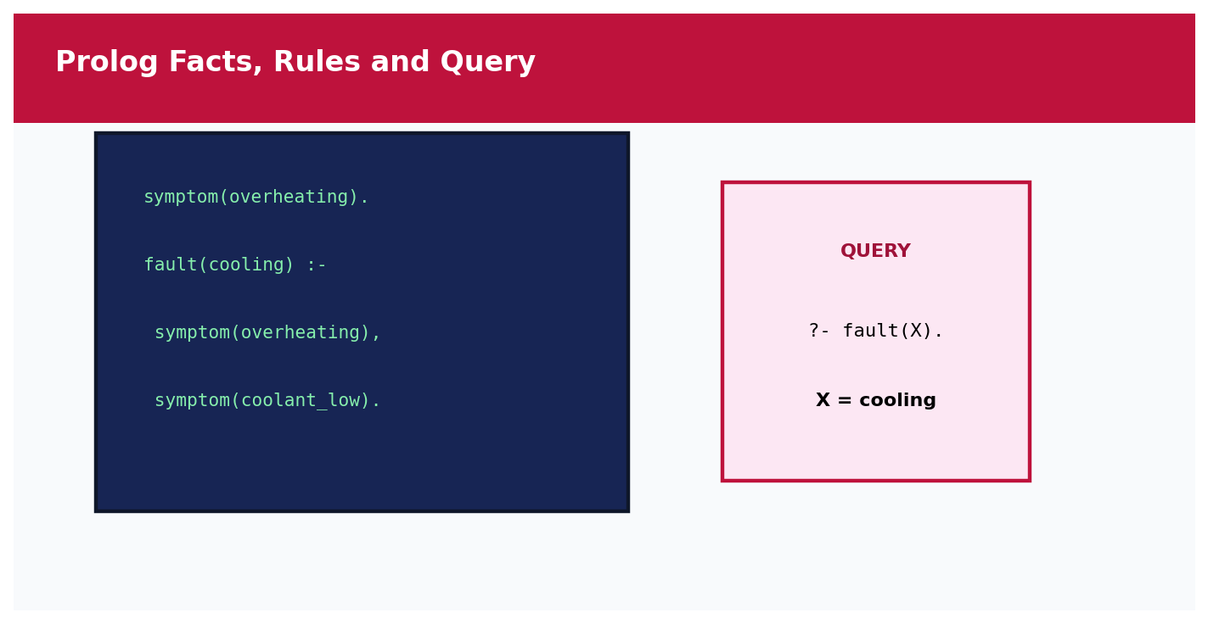
Prolog Facts, Rules and Query
Prolog Facts, Rules & Query
Prolog provides an executable form of the knowledge model through facts, rules, predicates and queries.
% Facts
symptom(engine_overheating).
symptom(coolant_low).
symptom(hard_start).
symptom(weak_battery).
symptom(abnormal_noise).
symptom(engine_vibration).
% Rules
fault(cooling_system_issue) :-
symptom(engine_overheating),
symptom(coolant_low).
fault(battery_starting_issue) :-
symptom(hard_start),
symptom(weak_battery).
fault(engine_mechanical_issue) :-
symptom(abnormal_noise),
symptom(engine_vibration).
action(cooling_system_issue,
'Check coolant level and inspect for leaks.').
action(battery_starting_issue,
'Test battery voltage and starting circuit.').
action(engine_mechanical_issue,
'Inspect mechanical components and mounts.').
diagnosis(Fault,Action) :-
fault(Fault),
action(Fault,Action).
?- fault(cooling_system_issue).
true.
?- diagnosis(Fault,Action).
Fault = cooling_system_issue,
Action = 'Check coolant level and inspect for leaks.'.
Prolog Representation

7. Forward & Backward Chaining Demonstration
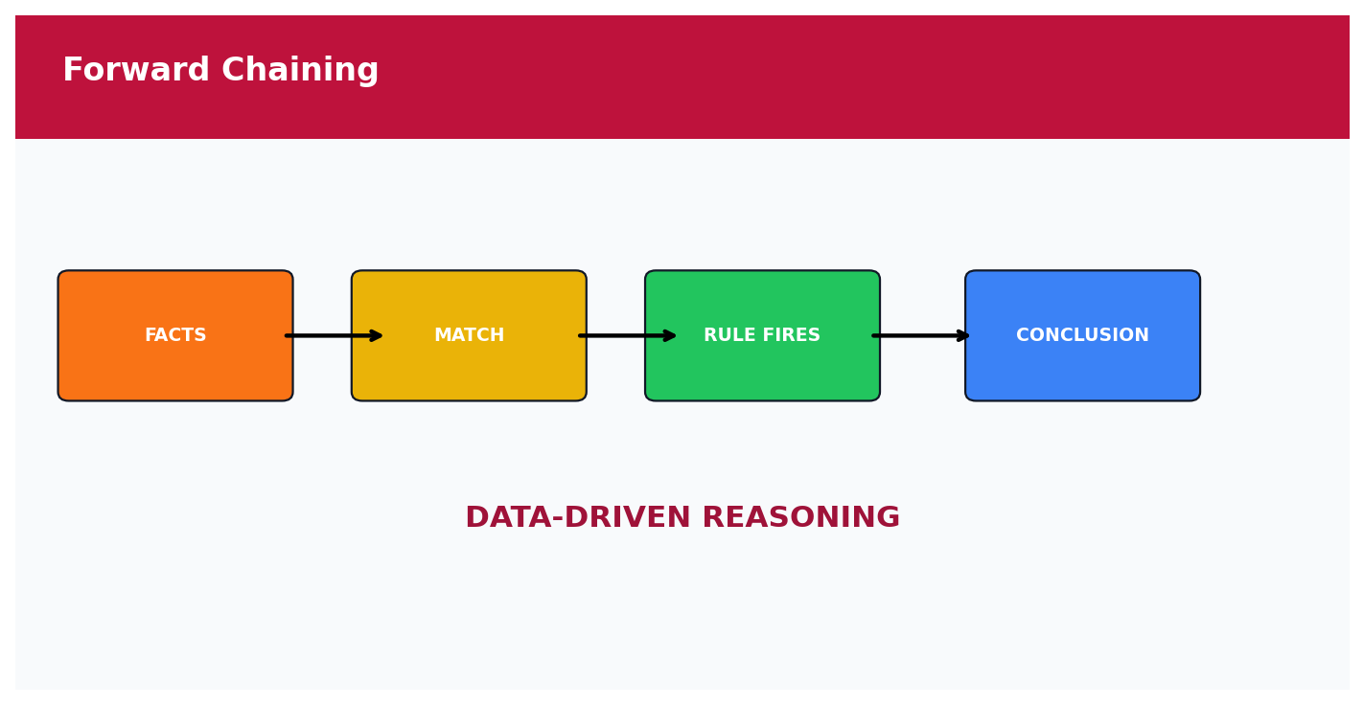
Forward Chaining
Forward Chaining Sequence
Forward vs Backward Chaining

7.1 Forward Chaining

Forward Chaining
Forward Chaining Sequence
Step | Inference
1 | Initial facts: engine_overheating, coolant_low
2 | Search for matching rules
3 | R1 conditions are satisfied
4 | Derive cooling_system_issue
5 | Recommend checking coolant and leaks

7.2 Backward Chaining
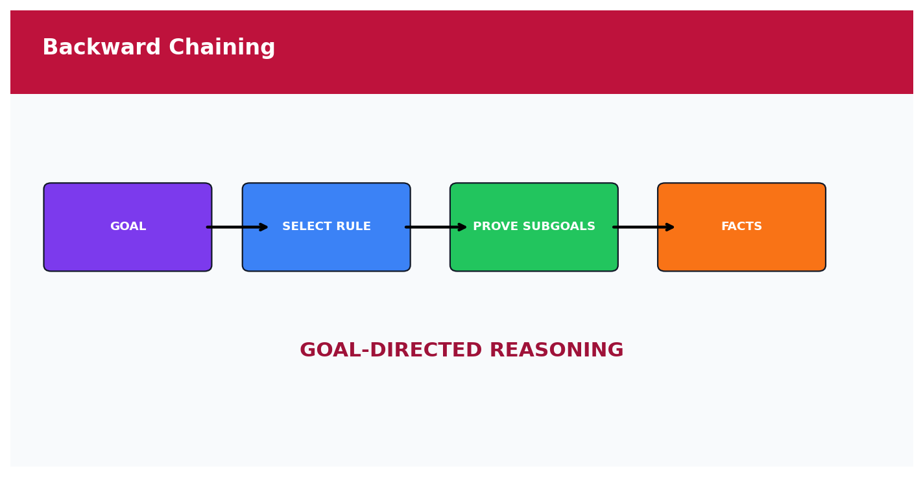
Backward Chaining
Backward Chaining Sequence
Step | Goal / Sub-goal
1 | Goal = cooling_system_issue
2 | Find rule R1
3 | engine_overheating → TRUE
4 | coolant_low → TRUE
5 | All sub-goals true → goal proved

7.3 Pseudocode
FORWARD CHAINING:
Start with known facts.
Find a rule whose conditions are true.
Add its conclusion.
Repeat until no new fact is derived.
BACKWARD CHAINING:
Start with a goal.
Find a rule that concludes the goal.
Prove each condition as a sub-goal.
If all succeed, the goal is proved.

8. Comparative Analysis
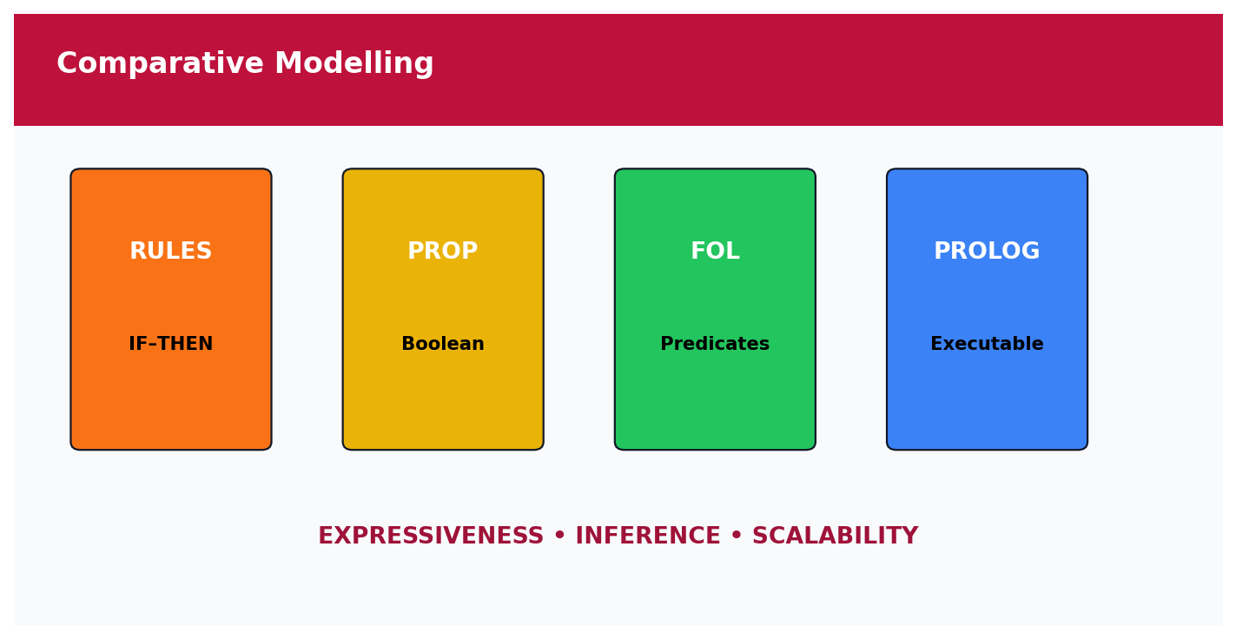
Comparative Modelling
Four-Model Comparison
Comparative Modelling View
Parameter | Production Rules | Propositional Logic | First-Order Logic | Prolog
Knowledge Representation | IF–THEN rules | Boolean propositions | Predicates + variables + quantifiers | Facts + rules
Expressiveness | Medium | Low–Medium | High | High
Rule Representation | Direct | Logical implication | General quantified rules | Natural executable rules
Inference | Rule firing | Logical entailment | Predicate inference | Search + backtracking
Forward Chaining | Natural | Possible | Possible | Implementable
Backward Chaining | Possible | Possible | Natural concept | Natural
Relationships | Limited | Weak | Strong | Strong
Scalability | Good | Limited for large domains | High representation power | Good
Explainability | High | High | High | High
Implementation | Easy | Moderate | Moderate–Hard | Easy–Moderate
Suitability | Good | Small fixed cases | Rich conceptual model | Best practical implementation

9. Results, Discussion & Model Selection

Automotive Observation Dashboard
Automotive Domain – Engine Observation Panel
The four models successfully represent the same automobile diagnosis knowledge, but their capabilities differ.
Model | Result
Production Rules | Highly readable and suitable for direct troubleshooting rules.
Propositional Logic | Clear for fixed true/false facts but weak for entity relationships.
First-Order Logic | Strongest formal representation for vehicles, components and relationships.
Prolog | Combines declarative representation with executable queries, inference and backtracking.

Recommended model: Prolog. It is the most suitable implementation because the assignment requires executable rules, queries, forward/backward reasoning, unification and backtracking. FOL provides the strongest conceptual relational representation, while Prolog provides the practical executable model.

10. Complexity, Flexibility & Scalability

Comparative Modelling
Four-Model Comparison
Model | Complexity / Scalability Observation
Production Rules | Rule matching grows with the number and complexity of rules.
Propositional Logic | Many Boolean combinations can become cumbersome as the domain grows.
First-Order Logic | Very expressive but quantified inference can be computationally expensive.
Prolog | Search/backtracking can grow with alternatives, but the rule base is highly extensible.

11. Limitations & Improvements

Prolog Facts, Rules and Query
Prolog Facts, Rules & Query
- The knowledge base is simplified and does not cover every automobile fault.
- Real diagnosis also requires sensor readings, vehicle model, maintenance history and diagnostic codes.
- Some symptoms can indicate multiple faults.
- Future versions can integrate OBD-II codes, live sensor data, confidence scores and a graphical interface.
- An explanation module can show the exact facts and rules responsible for each conclusion.
Automotive Domain – Observable Facts

12. Documentation, GitHub Repository & Presentation

Prolog Facts, Rules and Query
Prolog Facts, Rules & Query
automobile-modelling-at3/
|-- production_rules.txt
|-- propositional_model.txt
|-- fol_model.txt
|-- automobile_expert.pl
|-- test_cases.txt
|-- README.md
|-- screenshots/
| |-- prolog_output.png
| |-- forward_chain.png
| `-- backward_chain.png
`-- report/
`-- CO5_AT3_Sahil J.S_192525200.docx
The repository should contain all four modelling approaches, Prolog code, test cases, outputs and the final report.

13. Conclusion
The Automobile Fault Diagnosis problem was modelled using production rules, propositional logic, first-order logic and Prolog. Production rules provide a direct and readable representation, propositional logic is useful for fixed Boolean facts, FOL provides richer relationships and variables, and Prolog offers an executable rule-based environment with querying, unification and backtracking. Therefore, Prolog is recommended as the practical implementation model, supported by FOL for richer conceptual representation.

14. Viva Questions & Answers
Question | Answer
Why compare four models? | To study differences in expressiveness, inference and implementation.
Why is propositional logic limited? | It handles fixed true/false propositions and does not naturally model variables and rich relationships.
Main advantage of FOL? | It represents entities, relationships, variables and quantifiers.
Why Prolog? | It provides facts, rules, queries, unification and backtracking.
Forward chaining? | Fact-driven reasoning from observations to conclusions.
Backward chaining? | Goal-driven reasoning from a target conclusion to supporting facts.
Recommended model? | Prolog for practical implementation; FOL for rich conceptual representation.
What is backtracking? | Searching alternative clauses after returning to a previous choice point.

15. References
- SIMATS Engineering, Assessment Tool 3: Modelling Comparative Analysis Assignment, Artificial Intelligence and Expert Systems (MLA01).
- SWI-Prolog Documentation and Reference.
- Bratko, I., Prolog Programming for Artificial Intelligence, Pearson.
- Russell, S. and Norvig, P., Artificial Intelligence: A Modern Approach, Pearson.
- Giarratano, J. and Riley, G., Expert Systems: Principles and Programming.

16. Rubric Coverage Checklist
Criterion | Covered Section
Problem Analysis and Domain Understanding | 1
Domain Knowledge and Fact Identification | 2
Production Rule Modelling | 3
Propositional Logic Modelling | 4
First-Order Logic Modelling | 5
Prolog Modelling and Implementation | 6
Forward and Backward Chaining | 7
Comparative Analysis | 8–10
Results, Discussion and Model Selection | 9
Documentation, GitHub and Presentation | 12

Visual Appendix – Modelling Overview
Automotive Domain – Engine Observation Panel
Production Rule Knowledge Base
Propositional Logic Representation
First-Order Logic – Entities & Relationships
Prolog Facts, Rules & Query
Forward Chaining Sequence
Backward Chaining Sequence
Four-Model Comparison

VISUAL APPENDIX – SAHIL J.S

Automotive Observation Dashboard

Production Rule Knowledge Base

Propositional Logic Model

First-Order Logic Relationships

Prolog Facts, Rules and Query

Forward Chaining

Backward Chaining

Comparative Modelling

